1. **INTRODUCTION**

**OVERVIEW**

This report discusses the result of the work done in development of “Bulk Email Aggregator” on JavaScript Platform. The project aims at the development of an application to enable Customer Relationship Managers of a company to send bulk emails for collecting feedback of their own electronic products.

**BACKGROUND AND MOTIVATION**

Electronic product companies assign the task of collecting feedback to the CRM’s.

Companies like Croma send text messages to customers to collect feedback where they have to send individual messages to each person.

Therefore, with this system we are trying to send emails to collect feedback from the customers who had purchased products from their company much more efficiently and getting abstract of performance of the electronics in the market.

**OBJECTIVE**

The final goal of the project is twofold.

1. A web application that is used to provide a paid service to the end user which will enable them to send bulk emails for collecting feedback of their own electronic products once they do payment through the Stripe payment gateway which we have used in the application. This application uses **Google OAuth authentication** that will enhance the authentication in the app.
2. This application provides service based on assigned credit points to the user. Therefore, once the CRM who will be using the application does payment, 5 credit points will be incremented to the person’s account and he can send emails with this credit. Each time the CRM sends a mail, 1 credit point gets deduced.

**METHODOLOGY**

To implement the above goals, the following methodology needs to be followed:

1. Specifying the application and various components of the architecture.
2. Specifying the bindings between the various modules and JavaScript packages.
3. Specifying the server ports between the modules.
4. Analysis: Extracting the required data for analysis and then doing the analysis.

**ANALYSIS**

On the basis of analysis and literature survey regarding the present difficulties faced by the CRM’s of companies like Croma as they have to send individual emails or text messages to collect feedback from each person.

With this application, it is sending bulk emails to collect feedback from the customers who has purchased products from their company much more efficiently and getting abstract of performance of the electronics in the market.

Secondly, this application works based on assigned credit points to user. Therefore, once the CRM does transaction through this app, 5 credit points will be automatically added to the account and the user can make the best use of the credit points to send bulk email as 1 credit point get deduced each time a mail is sent.

**REQUIREMENTS ANALYSIS**:

**SOFTWARE REQUIREMENTS**:

Operating System: Windows 10 / Ubuntu

Front end: React.js v16.x

Back end: Node.js v11.x

Database: MongoDB Atlas

Authentication API: Google OAuth

Payment Gateway API: Stripe

Cloud Deployment: Heroku Deployment

Other Technologies used: Twilio SendGrid, Git and GitHub

**HARDWARE REQUIREMENTS:**

RAM: 8GB and above

Hard disk: 120GB and above

Processor: Intel i3 and above

**FUNCTIONAL REQUIREMENTS**:

1. CRM Signs Up via **Google OAuth.**
2. CRM **Pays for email credits** via Stripe.
3. CRM **creates a new feedback.**
4. CRM **enters list of emails to collect feedback.**
5. Application **send emails to list of customers.**
6. **Customers click on the link provided in the email to send feedback.**
7. Application will **tabulate feedback received**.
8. CRM **can see list of all feedback responses.**
9. Logout

**NON-FUNCTIONAL REQUIREMENTS**:

1. **Availability**: It will be available only to those who purchase this application.
2. **Maintainability**: It is easy to maintain the code base through Git.
3. **Performance**: We have configured our application in such a way that even though the load increases, the performance of our application doesn’t get affected.
4. **Supportability**: Our application will be able to run on all the platforms like Laptop, Mobile, Tablet etc.

**TOOLS AND TECHNOLOGIES**:

**APPLICATION DEVELOPMENT TECHNOLOGIES**:

This application is built using MERN stack ie MongoDB (MongoDB Atlas), Express, React.js and Node.js.

**MongoDB** is an open-source database software which is NoSQL in architecture. It stores data as JSON document. It is fast, reliable and efficient.

**Express** is a web application framework for Node.js. It is designed for building web applications and APIs. It has been called the de facto standard server framework for Node.js.

**React.js** is a JavaScript library for building user interfaces. Facebook and a community of individual developers and companies maintain it. React can be used as a base in the development of single-page or mobile applications.

**Node.js®** is a JavaScript runtime built on [Chrome's V8 JavaScript engine](https://v8.dev/).

**Google OAuth** use the [OAuth 2.0 protocol](http://tools.ietf.org/html/rfc6749) for authentication and authorization. Google supports common OAuth 2.0 scenarios such as those for web server, installed, and client-side applications.

**Stripe** is a service that allows users to accept payments online, specifically developers. With the **Stripe** application, users can keep track of payments, search past payments, create recurring charges, and keep track of customers.

**Twilio SendGrid** provides a [cloud-based](https://en.wikipedia.org/wiki/Cloud_computing) service that assists businesses with email delivery.

**INTEGRATION TOOLS**:

**GIT AND GITHUB**:

Git is a distributed version-control system for tracking changes in source code during software development. It is designed for coordinating work among programmers, but it can be used to track changes in any set of files. Its goals include speed, data integrity and support for distributed, non-linear workflows.

GitHub is a web based hoisting service for version control using Git. It is mostly used for computer code. It offers all of the distributed version control and source code management functionality of Git as adding its own features.

**HEROKU**:

**Heroku** is a container-based cloud Platform as a Service (PaaS). Developers use **Heroku** to deploy, manage, and scale modern apps. Our platform is elegant, flexible, and easy to use, offering developers the simplest path to getting their apps to market.

**DESIGN**

**DFD**

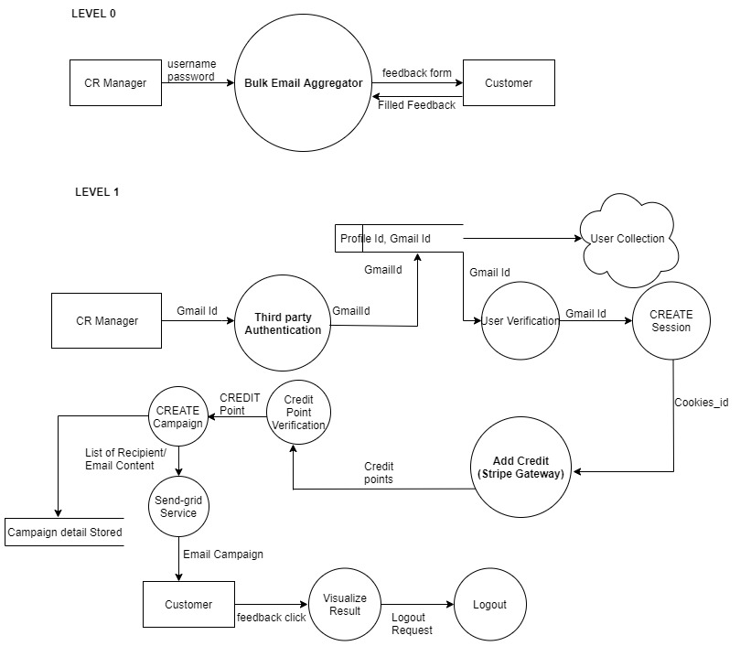

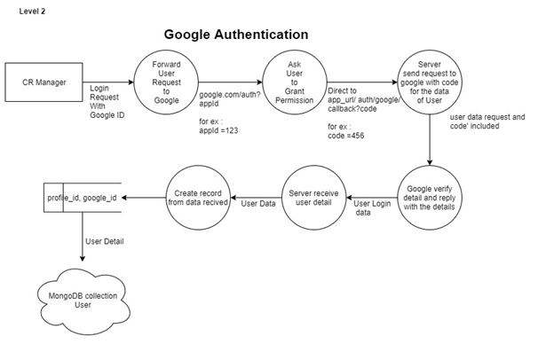

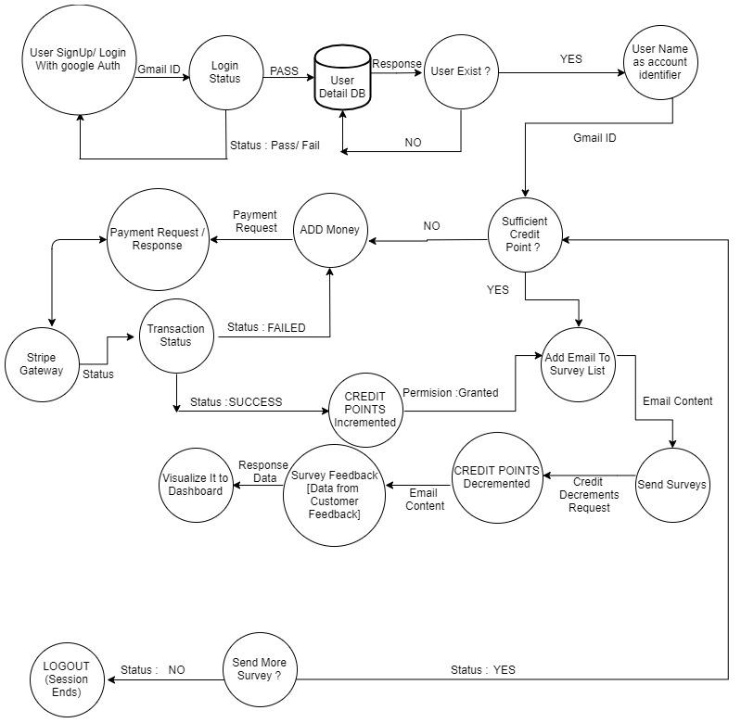

**DOCUMENT STRUCTURE**

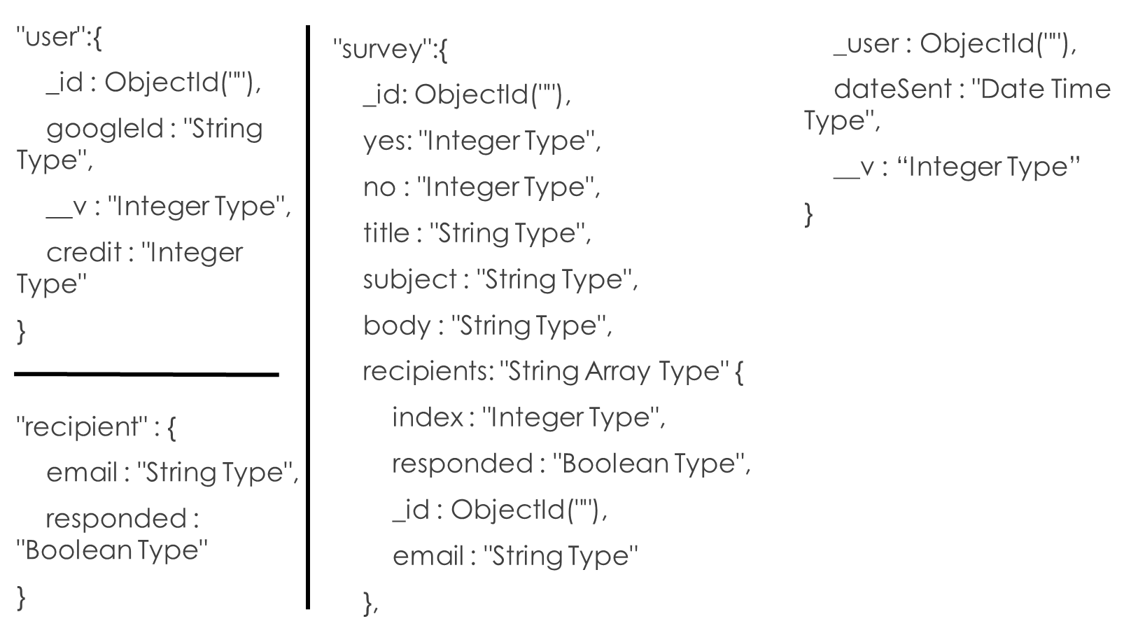

**USE CASE DIAGRAM**

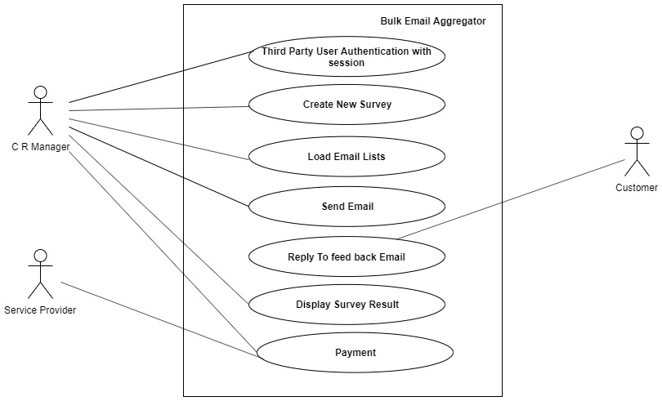

Our project consists of two folds:

1. Customer Relationship Manager (CRM).
2. Customers: Who purchase products from different electronic companies.

**IMPLEMENTATION**

**LOGIN SCREEN**

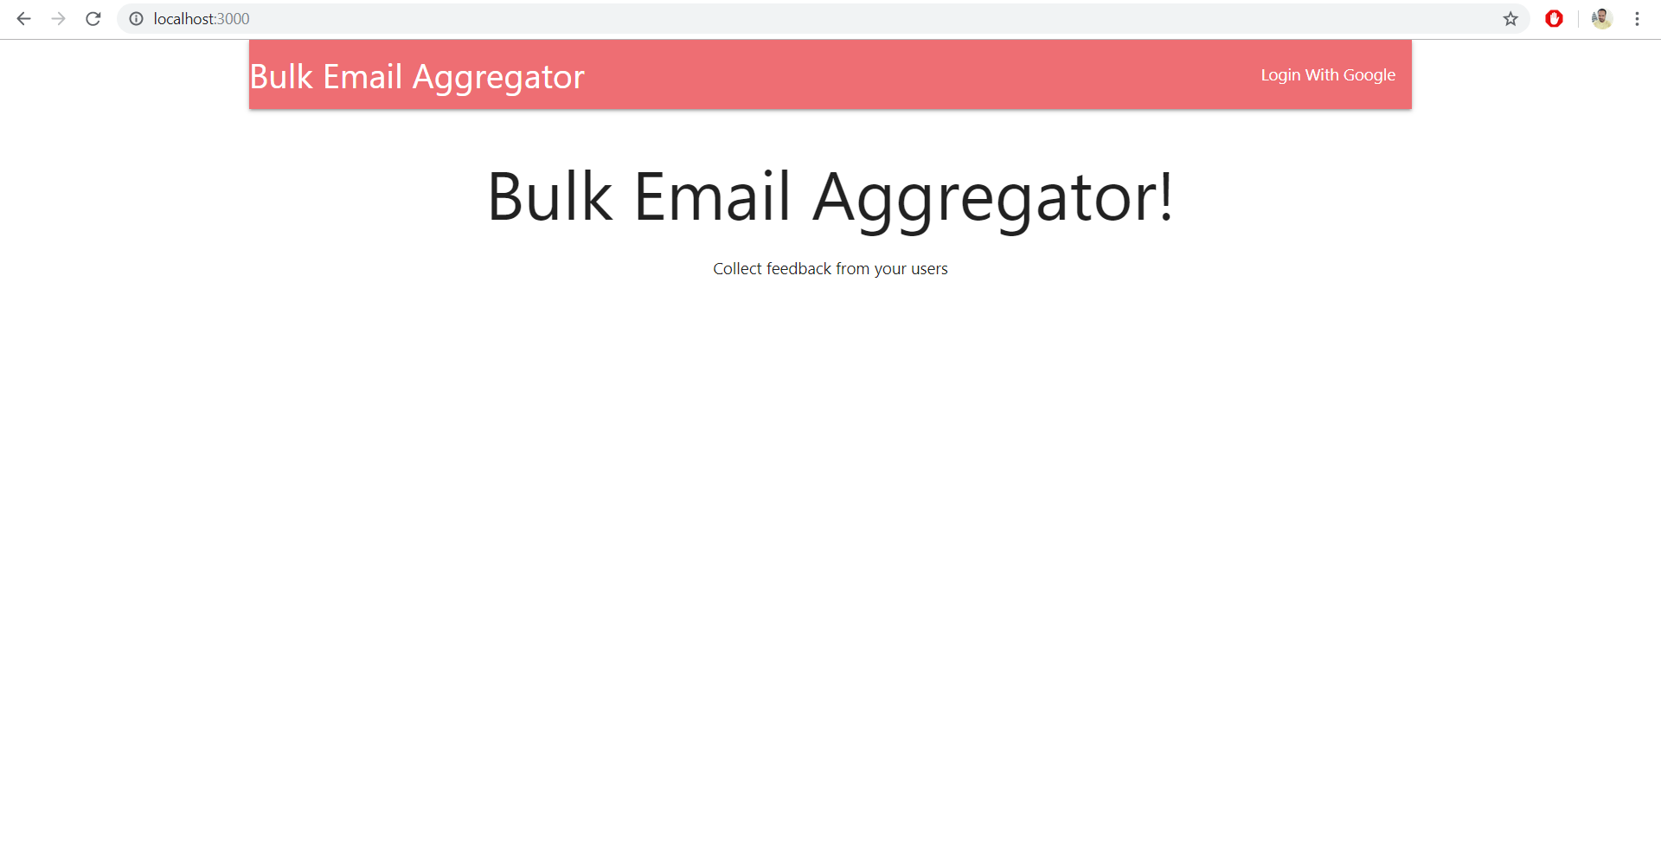

**HOMEPAGE**

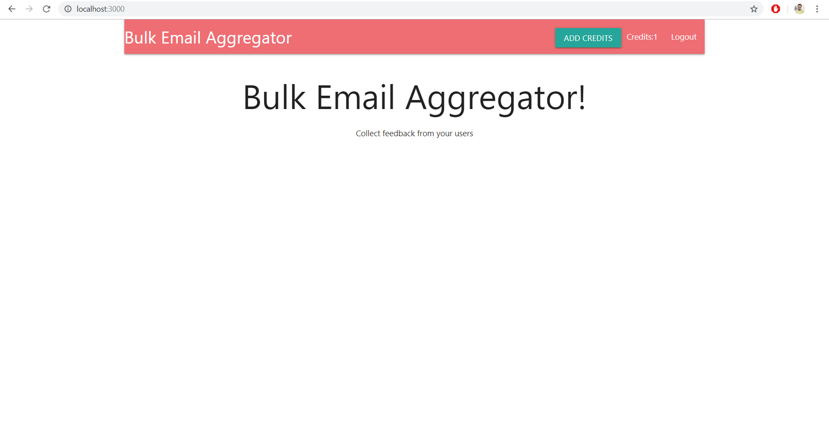

**DASHBOARD**

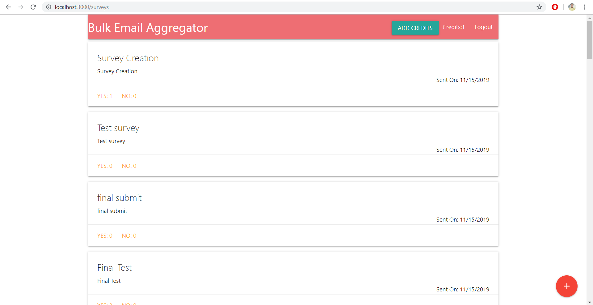

**FEEDBACK FORM**

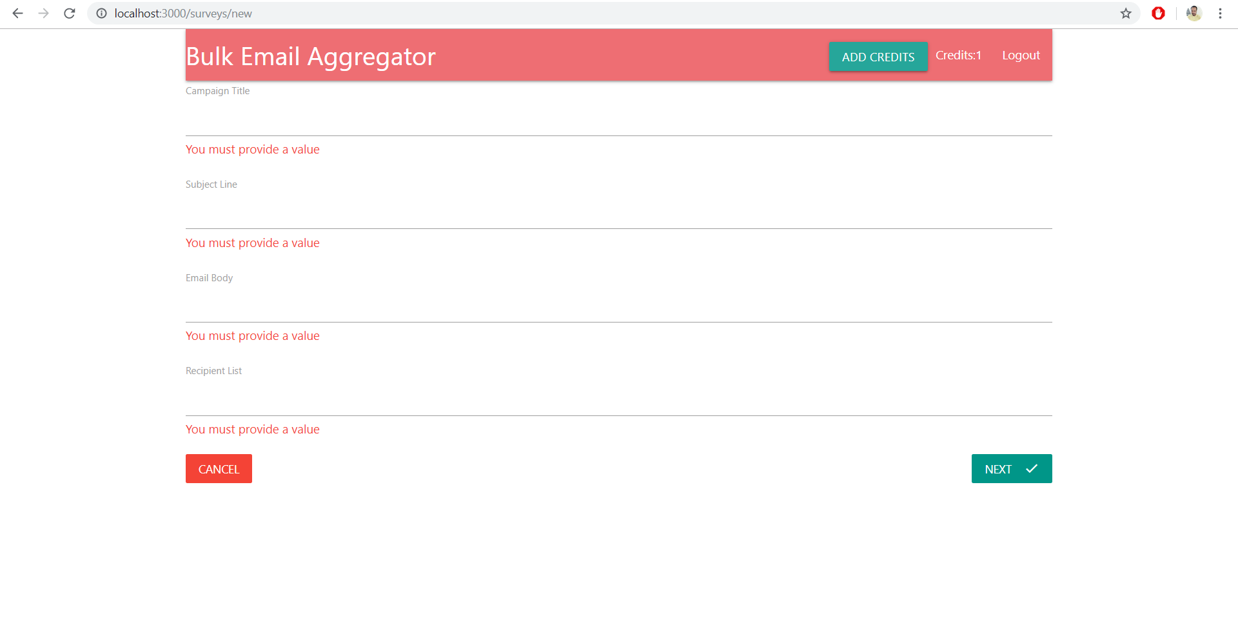

**REVIEW PAGE**

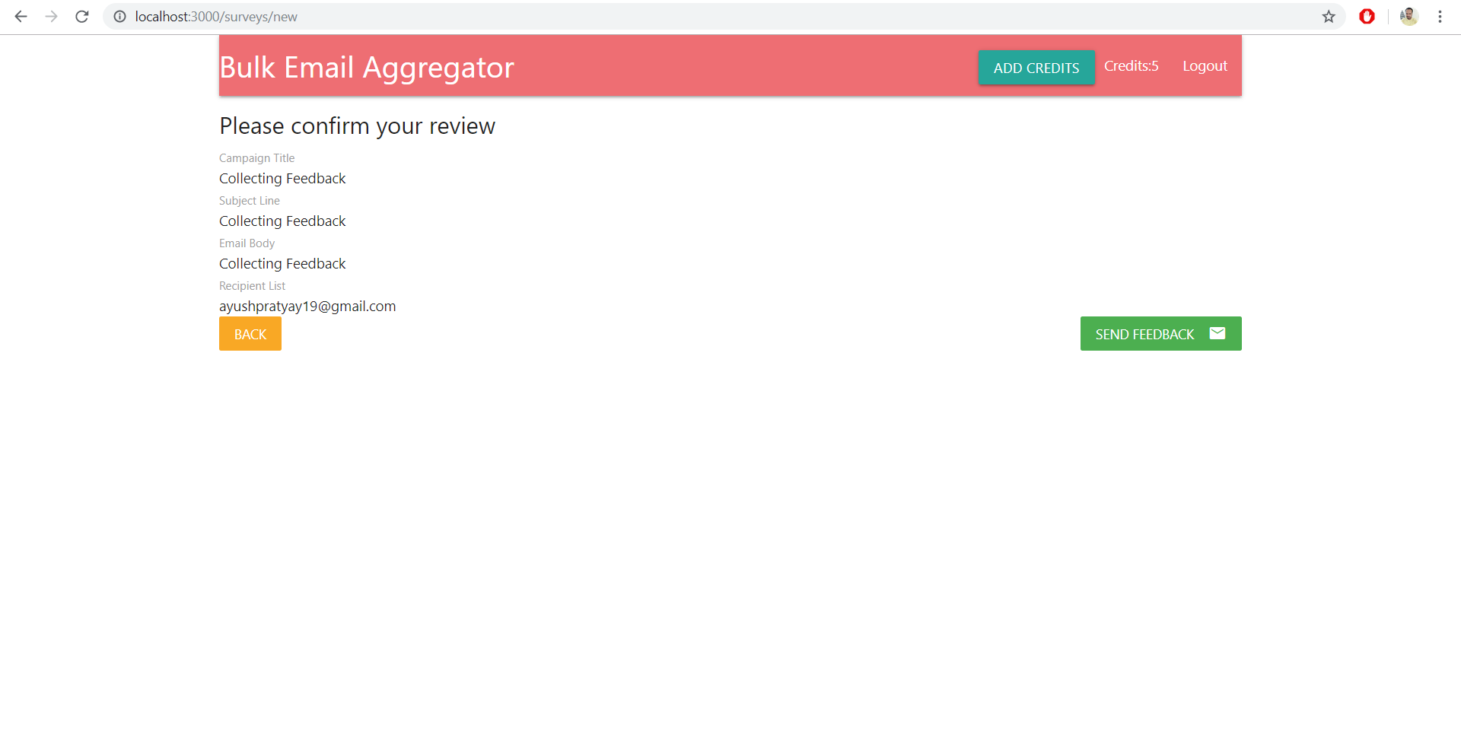

**USER RECEIVING FEEDBACK**

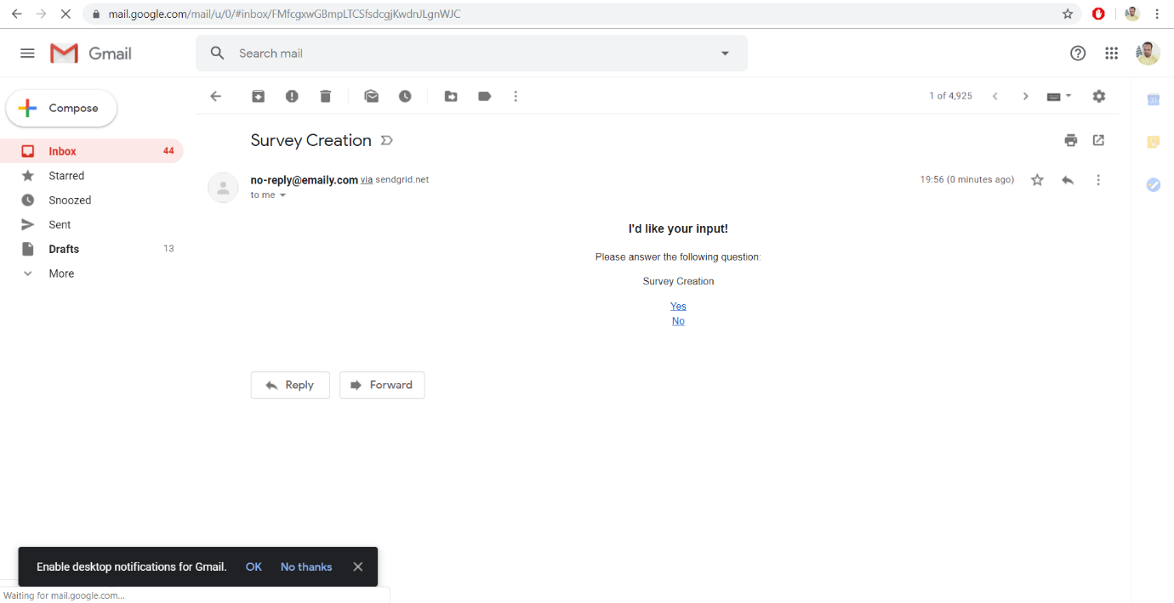

**USER RECEIVES CONFIRMATION**

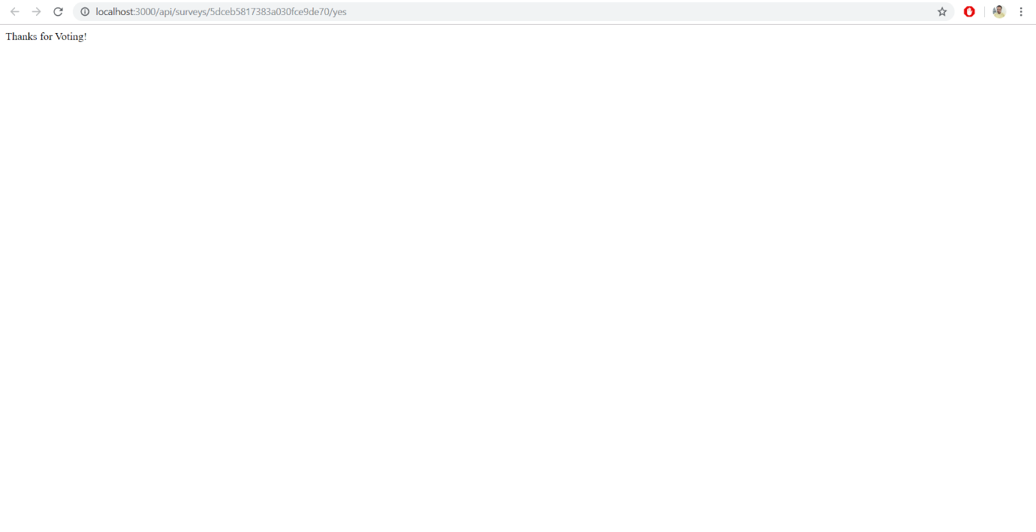

**STRIPE**

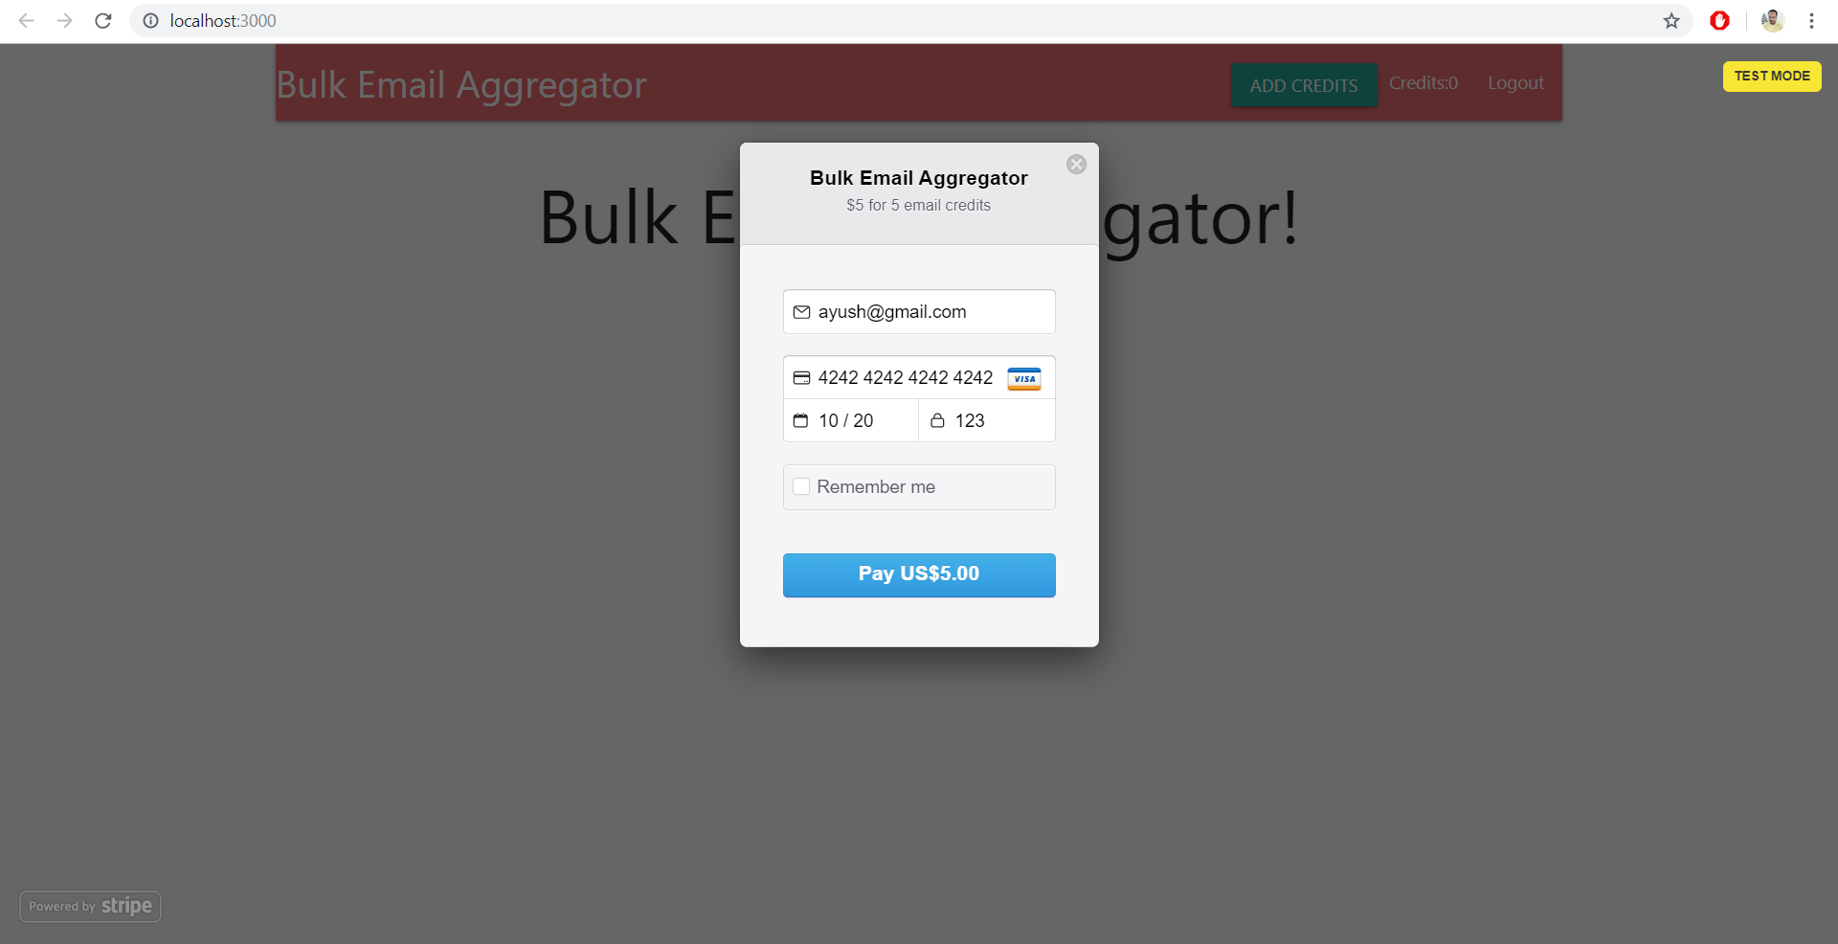

**MONGODB STRUCTURE**

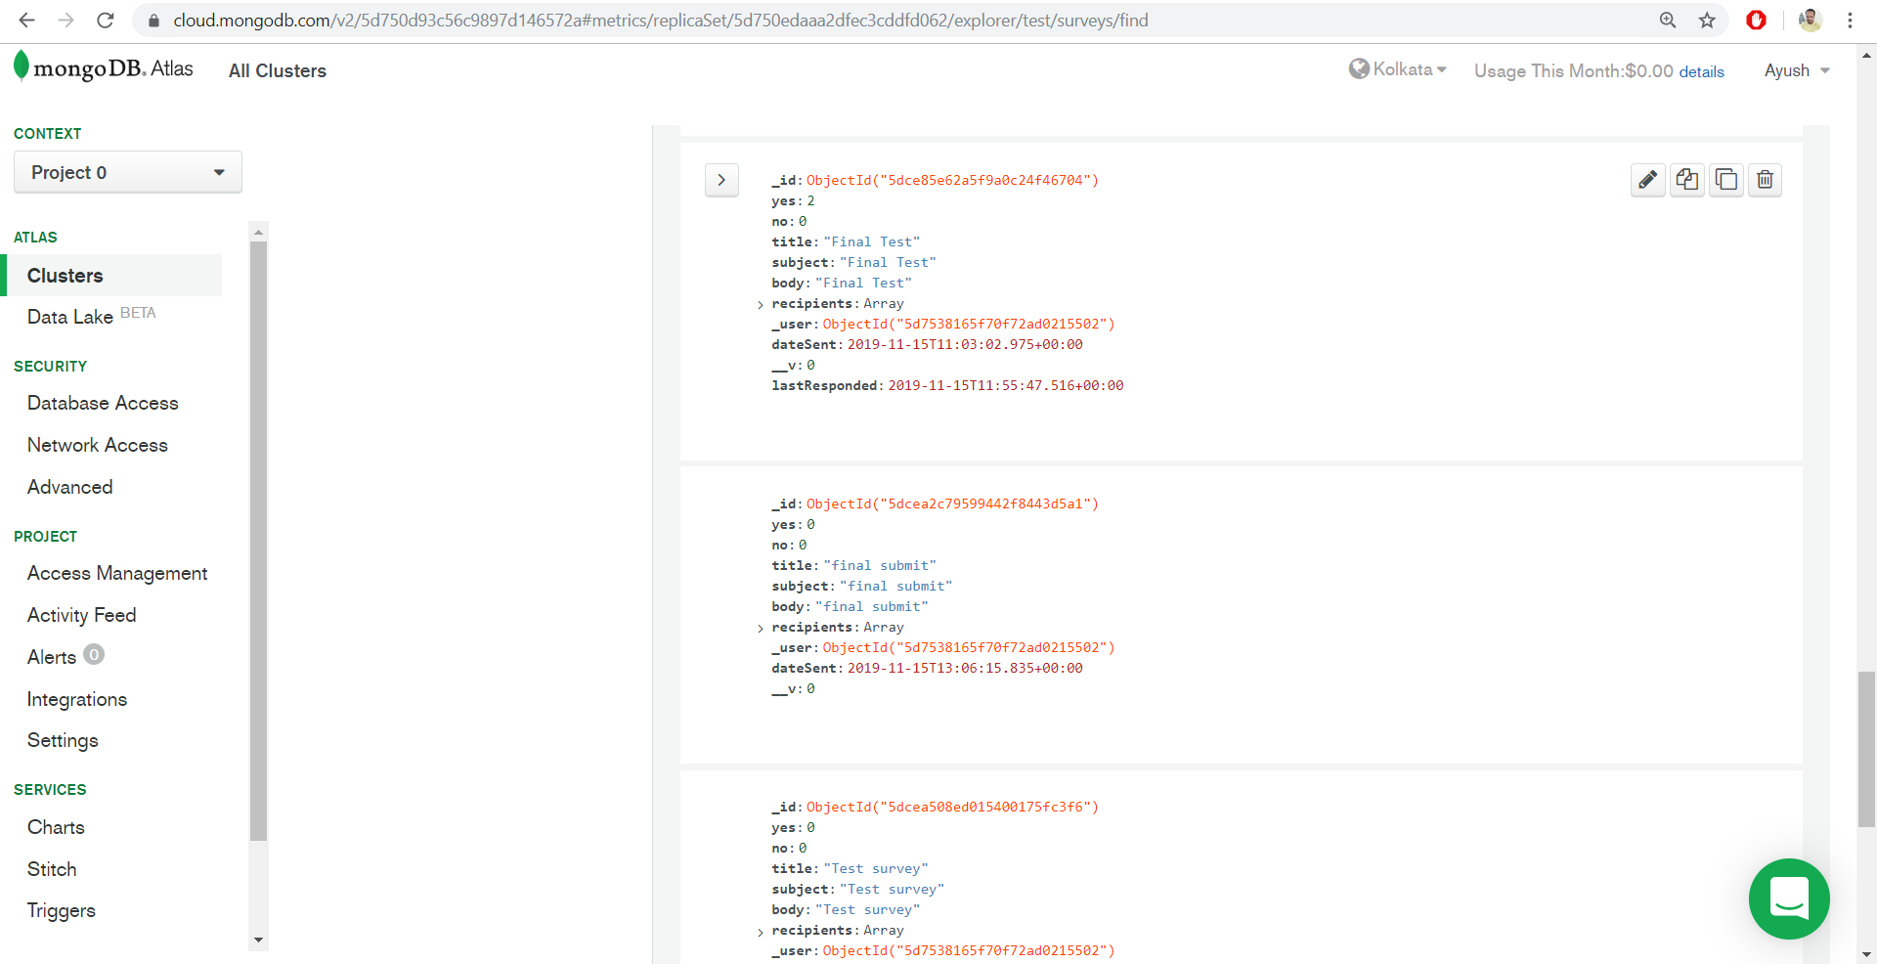

**TESTING**

|  |  |  |  |  |  |  |  |  |  |  |  |
| --- | --- | --- | --- | --- | --- | --- | --- | --- | --- | --- | --- |
| **Test Case ID** | | PES_001 | **Test Case Description** | | Test the Login Functionality in login screen | | | | | | |
| **Created By** | |  | **Reviewed By** | | - | | | **Version** | | 1 | |
|  |  |  |  |  |  |  |  | |  |  |  | |
| **QA Tester’s Log** | |  | | | |  |  | |  |  |  | |
|  |  |  |  |  |  |  |  | |  |  |  | |
| **Tester's Name** | |  | **Date Tested** | | 17-Nov-2019 | | | **Test Case (Pass/Fail/Not Executed)** | | Pass | |

|  |  |  |  |  |  |  |  |  |  |  |  |
| --- | --- | --- | --- | --- | --- | --- | --- | --- | --- | --- | --- |
| **S #** | **Prerequisites:** | | |  | **S #** | **Test Data** | | | | | |
| 1 | Access to Chrome Browser | | |  | 1 | E-mail = vijaykumarrpai@gmail.com | | | | | |
| 2 | <https://sheltered-reef-50053.herokuapp.com/> | | |  | 2 |  | | | | | |
| 3 |  | | |  | 3 |  | | | | | |
| 4 |  | | |  | 4 |  | | | | | |
|  |  |  |  |  |  |  | |  | | |  |
| **Test Scenario** | Verify on clicking Login With Google, the user logs into the application using his/her google account | | | | | |  | |  |  | |
|  |  |  |  |  |  |  | |  | | |  |
| **Step #** | **Step Details** | | **Expected Results** | | **Actual Results** | | | | | | **Pass / Fail / Not executed / Suspended** |
|
| 1 | Navigate to <https://sheltered-reef-50053.herokuapp.com/> | | Logged into application after clicking Login With Google | | User is logged in | | | | | | Pass |
| 2 | Page displayed | | Page should be redirected to <https://sheltered-reef-50053.herokuapp.com/surveys> | | Home Page is displayed | | | | | | Pass |
|  |  | |  | |  | | | | | |  |

|  |  |  |  |  |  |  |  |  |  |  |  |
| --- | --- | --- | --- | --- | --- | --- | --- | --- | --- | --- | --- |
| **Test Case ID** | | PES_002 | **Test Case Description** | | Test the functionality of creating new feedback form with 0 credits | | | | | | |
| **Created By** | |  | **Reviewed By** | | - | | | **Version** | | 1 | |
|  |  |  |  |  |  |  |  | |  |  |  | |
| **QA Tester’s Log** | |  | | | |  |  | |  |  |  | |
|  |  |  |  |  |  |  |  | |  |  |  | |
| **Tester's Name** | |  | **Date Tested** | | 17-Nov-2019 | | | **Test Case (Pass/Fail/Not Executed)** | | Fail | |

|  |  |  |  |  |  |  |  |  |  |  |  |
| --- | --- | --- | --- | --- | --- | --- | --- | --- | --- | --- | --- |
| **S #** | **Prerequisites:** | | |  | **S #** | **Test Data** | | | | | |
| 1 | Access to Chrome Browser | | |  | 1 | Campaign title - Test | | | | | |
| 2 | <https://sheltered-reef-50053.herokuapp.com/> | | |  | 2 | Subject Line - Test | | | | | |
| 3 |  | | |  | 3 | Email Body – This is a test data | | | | | |
| 4 |  | | |  | 4 | Recipient list – vijaykumarrpai@gmail.com,........ | | | | | |
|  |  | | |  | 5 |  | | | | | |
|  |  | | |  | 6 |  | | | | | |
|  |  |  |  |  |  |  | |  | | |  |
| **Test Scenario** | Creating new feedback form on clicking + button followed by entering the required details | | | | | |  | |  |  | |
|  |  |  |  |  |  |  | |  | | |  |
| **Step #** | **Step Details** | | **Expected Results** | | **Actual Results** | | | | | | **Pass / Fail / Not executed / Suspended** |
|
| 1 | Navigate to <https://sheltered-reef-50053.herokuapp.com/surveys/new> | | Redirected to the feedback form creation page | | Successfully redirected | | | | | | Pass |
| 2 | Enter Campaign Title, Subject Line, Email Body, Recipient List | | Should redirect to next page on clicking next button | | Successfully redirected | | | | | | Pass |
| 3 | Confirm the details and click on Send Feedback | | Should successfully create new feedback form | | Failed to create because there are no credits in the account | | | | | | Fail |

|  |  |  |  |  |  |  |  |  |  |  |  |
| --- | --- | --- | --- | --- | --- | --- | --- | --- | --- | --- | --- |
| **Test Case ID** | | PES_003 | **Test Case Description** | | Test the functionality of creating new feedback form. | | | | | | |
| **Created By** | |  | **Reviewed By** | | - | | | **Version** | | 1 | |
|  |  |  |  |  |  |  |  | |  |  |  | |
| **QA Tester’s Log** | |  | | | |  |  | |  |  |  | |
|  |  |  |  |  |  |  |  | |  |  |  | |
| **Tester's Name** | |  | **Date Tested** | | 17-Nov-2019 | | | **Test Case (Pass/Fail/Not Executed)** | | Pass | |

|  |  |  |  |  |  |  |  |  |  |  |  |
| --- | --- | --- | --- | --- | --- | --- | --- | --- | --- | --- | --- |
| **S #** | **Prerequisites:** | | |  | **S #** | **Test Data** | | | | | |
| 1 | Access to Chrome Browser | | |  | 1 | Campaign title - Test | | | | | |
| 2 | <https://sheltered-reef-50053.herokuapp.com/> | | |  | 2 | Subject Line - Test | | | | | |
| 3 |  | | |  | 3 | Email Body – This is a test data | | | | | |
|  |  | | |  | 4 | Recipient list – vijaykumarrpai@gmail.com,........ | | | | | |
|  |  |  |  |  |  |  | |  | | |  |
| **Test Scenario** | Creating new feedback form on clicking + button followed by entering the required details | | | | | |  | |  |  | |
|  |  |  |  |  |  |  | |  | | |  |
| **Step #** | **Step Details** | | **Expected Results** | | **Actual Results** | | | | | | **Pass / Fail / Not executed / Suspended** |
|
| 1 | Navigate to <https://sheltered-reef-50053.herokuapp.com/surveys/new> | | Redirected to the feedback form creation page | | Successfully redirected | | | | | | Pass |
| 2 | Enter Campaign Title, Subject Line, Email Body, Recipient List | | Should redirect to next page on clicking next button | | Successfully redirected | | | | | | Pass |
| 3 | Confirm the details and click on Send Feedback | | Should successfully create new feedback form | | Successfully created new feedback and sent to the entered email id | | | | | | Pass |

|  |  |  |  |  |  |  |  |  |  |  |  |
| --- | --- | --- | --- | --- | --- | --- | --- | --- | --- | --- | --- |
| **Test Case ID** | | PES_004 | **Test Case Description** | | Test the functionality of creating new feedback form. | | | | | | |
| **Created By** | |  | **Reviewed By** | | - | | | **Version** | | 1 | |
|  |  |  |  |  |  |  |  | |  |  |  | |
| **QA Tester’s Log** | |  | | | |  |  | |  |  |  | |
|  |  |  |  |  |  |  |  | |  |  |  | |
| **Tester's Name** | |  | **Date Tested** | | 17-Nov-2019 | | | **Test Case (Pass/Fail/Not Executed)** | | Pass | |

|  |  |  |  |  |  |  |  |  |  |  |  |
| --- | --- | --- | --- | --- | --- | --- | --- | --- | --- | --- | --- |
| **S #** | **Prerequisites:** | | |  | **S #** | **Test Data** | | | | | |
| 1 | Access to Chrome Browser | | |  | 1 | Campaign title - | | | | | |
| 2 | <https://sheltered-reef-50053.herokuapp.com/> | | |  | 2 | Subject Line - | | | | | |
| 3 |  | | |  | 3 | Email Body – | | | | | |
|  |  | | |  | 4 | Recipient list – | | | | | |
|  |  |  |  |  |  |  | |  | | |  |
| **Test Scenario** | Creating new feedback form on clicking + button followed by entering the required details | | | | | |  | |  |  | |
|  |  |  |  |  |  |  | |  | | |  |
| **Step #** | **Step Details** | | **Expected Results** | | **Actual Results** | | | | | | **Pass / Fail / Not executed / Suspended** |
|
| 1 | Navigate to <https://sheltered-reef-50053.herokuapp.com/surveys/new> | | Redirected to the feedback form creation page | | Successfully redirected | | | | | | Pass |
| 2 | Did not fill any field | | Should say ‘You must provide a value’ | | Says ‘You must provide a value’ | | | | | | Pass |
| 3 | Click Next | | Should not go to review page | | Did not redirect to review page | | | | | | Pass |

|  |  |  |  |  |  |  |  |  |  |  |  |
| --- | --- | --- | --- | --- | --- | --- | --- | --- | --- | --- | --- |
| **Test Case ID** | | PES_005 | **Test Case Description** | | Adding Credits through Stripe Gateway | | | | | | |
| **Created By** | |  | **Reviewed By** | | - | | | **Version** | | 1 | |
|  |  |  |  |  |  |  |  | |  |  |  | |
| **QA Tester’s Log** | |  | | | |  |  | |  |  |  | |
|  |  |  |  |  |  |  |  | |  |  |  | |
| **Tester's Name** | |  | **Date Tested** | | 17-Nov-2019 | | | **Test Case (Pass/Fail/Not Executed)** | | Pass | |

|  |  |  |  |  |  |  |  |  |  |  |  |
| --- | --- | --- | --- | --- | --- | --- | --- | --- | --- | --- | --- |
| **S #** | **Prerequisites:** | | |  | **S #** | **Test Data** | | | | | |
| 1 | Access to Chrome Browser | | |  | 1 | Email – wdawda@awdawd.com | | | | | |
| 2 | <https://sheltered-reef-50053.herokuapp.com/> | | |  | 2 | Card number – **** **** **** **** | | | | | |
| 3 |  | | |  | 3 | Expiry date – 09/20 | | | | | |
|  |  | | |  | 4 | CVC - 123 | | | | | |
|  |  |  |  |  |  |  | |  | | |  |
| **Test Scenario** | Adding credits by clicking on Add Credits | | | | | |  | |  |  | |
|  |  |  |  |  |  |  | |  | | |  |
| **Step #** | **Step Details** | | **Expected Results** | | **Actual Results** | | | | | | **Pass / Fail / Not executed / Suspended** |
|
| 1 | Navigate to <https://sheltered-reef-50053.herokuapp.com/surveys> | | Should redirect successfully | | Redirected successfully | | | | | | Pass |
| 2 | Click on ‘Add Credits’ | | Should ask to enter card details | | Opened card details page | | | | | | Pass |
| 3 | Enter email, card no, expiry month and year and CVC | | Enter details | | Entered details | | | | | | Pass |
| 4 | Click on Pay | | Should increment credits | | Credits incremented | | | | | | Pass |

|  |  |  |  |  |  |  |  |  |  |  |
| --- | --- | --- | --- | --- | --- | --- | --- | --- | --- | --- |
| **Test Case ID** | | PES_006 | **Test Case Description** | | Adding Credits through Stripe gateway without entering card details | | | | | |
| **Created By** | |  | **Reviewed By** | | - | | **Version** | | 1 | |
|  |  |  |  |  |  |  |  |  |  |  |
| **QA Tester’s Log** | |  | | | |  |  |  |  |  |
|  |  |  |  |  |  |  |  |  |  |  |
| **Tester's Name** | |  | **Date Tested** | | 17-Nov-2019 | | **Test Case (Pass/Fail/Not Executed)** | | Pass | |
|  |  |  |  |  |  |  |  |  |  |  |
| **S #** | **Prerequisites:** | | |  | **S #** | **Test Data** | | | | |
| 1 | Access to Chrome Browser | | |  | 1 | Email – wdawda@awdawd.com | | | | |
| 2 | <https://sheltered-reef-50053.herokuapp.com/> | | |  | 2 | Card number – **** **** **** **** | | | | |
| 3 |  | | |  | 3 | Expiry date – 09/20 | | | | |
| 4 |  | | |  | 4 | CVC - 123 | | | | |
|  |  |  |  |  |  |  |  |  |  |  |
| **Test Scenario** | Adding credits by clicking on Add Credits | | | | | |  |  |  |  |
|  |  |  |  |  |  |  |  |  |  |  |
| **Step #** | **Step Details** | | **Expected Results** | | **Actual Results** | | | **Pass / Fail / Not executed / Suspended** | | |
|
| 1 | Navigate to <https://sheltered-reef-50053.herokuapp.com/surveys> | | Should redirect successfully | | Redirected successfully | | | Pass | | |
| 2 | Click on ‘Add Credits’ | | Should ask to enter card details | | Opened card details page | | | Pass | | |
| 3 | Did not enter email, card no, expiry month and year and CVC | | Details not entered | | Details not entered | | | Pass | | |
| 4 | Click on Pay | | Should not do any transaction and credit will not be incremented | | Did not do any transaction and credit not incremented | | | Pass | | |

|  |  |  |  |  |  |  |  |  |  |  |
| --- | --- | --- | --- | --- | --- | --- | --- | --- | --- | --- |
| **Test Case ID** | | PES_007 | **Test Case Description** | | Testing Logout functionality | | | | | |
| **Created By** | |  | **Reviewed By** | | - | | **Version** | | 1 | |
|  |  |  |  |  |  |  |  |  |  |  |
| **QA Tester’s Log** | |  | | | |  |  |  |  |  |
|  |  |  |  |  |  |  |  |  |  |  |
| **Tester's Name** | |  | **Date Tested** | | 17-Nov-2019 | | **Test Case (Pass/Fail/Not Executed)** | | Pass | |
|  |  |  |  |  |  |  |  |  |  |  |
| **S #** | **Prerequisites:** | | |  | **S #** | **Test Data** | | | | |
| 1 | Access to Chrome Browser | | |  | 1 |  | | | | |
| 2 | <https://sheltered-reef-50053.herokuapp.com/surveys> | | |  | 2 |  | | | | |
| 3 |  | | |  | 3 |  | | | | |
| 4 |  | | |  | 4 |  | | | | |
| 5 |  | | |  | 5 |  | | | | |
| 6 |  | | |  | 6 |  | | | | |
|  |  |  |  |  |  |  |  |  |  |  |
| **Test Scenario** | Verify on clicking logout button, the user is logged out | | | | | |  |  |  |  |
|  |  |  |  |  |  |  |  |  |  |  |
| **Step #** | **Step Details** | | **Expected Results** | | **Actual Results** | | | **Pass / Fail / Not executed / Suspended** | | |
|
| 1 | Navigate to <https://sheltered-reef-50053.herokuapp.com/surveys> | | Should redirect successfully | | Redirected successfully | | | Pass | | |
| 2 | Click on ‘Logout’ button | | Should logout out of the application | | Successfully logged out of the application | | | Pass | | |

|  |  |  |  |  |  |  |  |  |  |
| --- | --- | --- | --- | --- | --- | --- | --- | --- | --- |
| **Test Case ID** | | PES_008 | **Test Case Description** | | Testing by responding to feedback form received | | | | |
| **Created By** | |  | **Reviewed By** | | - | | **Version** | | 1 |
|  |  |  |  |  |  |  |  |  |  |  |
| **QA Tester’s Log** | |  | | | |  |  |  |  |  |
|  |  |  |  |  |  |  |  |  |  |  |
| **Tester's Name** | |  | **Date Tested** | | 17-Nov-2019 | | **Test Case (Pass/Fail/Not Executed)** | | Pass |
|  |  |  |  |  |  |  |  |  |  |  |
| **S #** | **Prerequisites:** | | |  | **S #** | **Test Data** | | | |
| 1 | Access to Chrome Browser | | |  | 1 | E-mail id = vijay@gmail.com | | | |
| 2 | Log into your registered email account | | |  | 2 | Pass = dawdawd | | | |
| 3 |  | | |  | 3 |  | | | |
| 4 |  | | |  | 4 |  | | | |
|  |  |  |  |  |  |  |  |  |  |  |
| **Test Scenario** | Verify while responding to the feedback, the response is recorded | | | | | |  |  |  |  |
|  |  |  |  |  |  |  |  |  |  |  |
| **Step #** | **Step Details** | | **Expected Results** | | **Actual Results** | | | **Pass / Fail / Not executed / Suspended** | |
|
| 1 | Navigate to Gmail account | | Logged into account | | Logged into account | | | Pass | |
| 2 | Respond to received feedback form | | Should able to click yes or no | | Response recorded | | | Pass | |
| 3 | Redirected to page saying ‘thank you for voting’ | | Redirect to the message page | | Redirected to the message page successfully | | | Pass | |

**CONCLUSION**

1. The objective of the project was to solve the difficulties faced by the CRM’s who have to send individual emails to each customer.
2. This has been solved with our application as it provides a paid service to end users which will enable them to send bulk emails for collecting feedback of their own electronic products.
3. In addition, the whole application has been deployed on Heroku platform. So in the future, if the user requests for any changes, it can be easily done through git version control.

**FUTURE ENHANCEMENTS**

1. Lot of features and functionalities can be integrated in our project. Firstly, we can group certain customers into one batch so that we can send bulk emails in one shot.
2. Secondly, we can build a customized Mobile app which will make user more convenient to use.

**BIBLIOGRAPHY**

1. https://www.coursera.com/
2. <https://www.edx.org/>
3. <https://www.npmjs.com/>
4. <https://developers.google.com/identity/protocols/OAuth2>
5. <https://stripe.com/docs/api>
6. <https://devcenter.heroku.com/categories/nodejs-support>
7. <https://sendgrid.com/docs/for-developers/>
8. <https://docs.mongodb.com/cloud/>